Royle Elementary School PTO 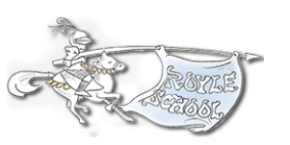
Check Request Form

Submission Date:
Name:
Payee/Vendor:
Payee/Vendor Address:
PTO Committee:
Name and Date of Event:
Committee Chair Approval:
Executive Board Approval*:

*Co-Chair or Treasurer approval needed for amounts > $500 and unbudgeted expenses of any amount.

Expense Date | Expense  Description | Expense Amount
 | Total

Scan all receipts and email the completed form to the Treasurer: RoyleTreasurer@gmail.com
with the Subject: “Royle Check Request – [Payee/Vendor Name]” or give to Ms. Presser in the Main Office.

All checks will be sent home via Ms. Presser at Royle unless other arrangements are made with the Treasurer to send a reimbursement check directly.

Reminder to vendors – do not include sales tax in invoice requests. Royle is tax exempt.

