Royle Elementary School PTO 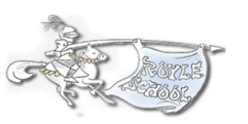
Teacher Expense Reimbursement Form

Instructions:
Include all receipts and submit a completed form to Ms. Presser, or send to
Susan Fiveson (Treasurer): RoyleTreasurer@gmail.com
Subject line: “Royle Check Request – Teacher Reimbursement”

Submission Date:
Teacher Name:
Grade:
Email Address:

Expense Date | Expense Description | Expense Amount
 | Total

All reimbursement checks will be available in the main office via Ms. Presser unless other arrangements are made with the Treasurer.

